SBM Snap

**1.volatile storage**: loses contents when power is switched off

**2.non-volatile storage**: Contents persist even when power is switched off.

**3.Cache** – fastest volatile

**4. Main memory**- fast access (10s to 100s of nanoseconds; 1 nanosecond = 10–9 seconds) generally too small Volatile

**5.Magnetic-disk** --Data is stored on spinning disk ,Much slower access than main memory,Capacities range up to roughly 16 TB

Survives power failures and system crashes

**6.Optical storage**---non-volatile,CD-ROM (640 MB) and DVD (4.7 to 17 GB) most popular forms

Blu-ray disks: 27 GB to 54 GB

Write-one, read-many (WORM) optical disks used for archival storage (CD-R, DVD-R, DVD+R)

Multiple write versions also available (CD-RW, DVD-RW, DVD+RW, and DVD-RAM)

Reads and writes are slower than with magnetic disk

**7.Tape storage** ---non-volatile,for backup ,

sequential-access – much slower than disk

very high capacity (40 to 900 GB tapes available)

Very Less Power consumptions

used for supercomputer data backup

Tape available for storing massive amounts of data

hundreds of terabytes (1 terabyte = 109 bytes) to even multiple petabytes (1 petabyte = 1012 bytes)

**8.Single Disk Drive--**---

Multiple disks connected to a computer system through a controller

DISK Type HDD, SSD, NVME ((non-volatile memory express) , optane

Disk interface standards families

ATA (AT adaptor) range of standards

SATA (Serial ATA)

SCSI (Small Computer System Interconnect) range of standards

SAS (Serial Attached SCSI)

**9. Storage Hierachy**---

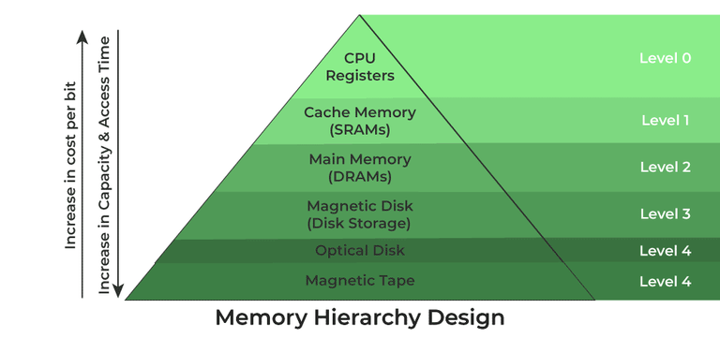

**1. Registers**

Registers are small, high-speed memory units located in the CPU.

They are used to store the most frequently used data and instructions.

Registers have the fastest access time and the smallest storage capacity, typically ranging from 16 to 64 bits.

**2. Cache Memory**--

Cache memory is a small, fast memory unit located close to the CPU

Cache memory is designed to minimize the time it takes to access data by providing the CPU with quick access to frequently used data.

**3. Main Memory**

Main memory, also known as RAM (Random Access Memory), is the primary memory of a computer system. It has a larger storage capacity than cache memory, but it is slower. Main memory is used to store data and instructions that are currently in use by the CPU.

Types of Main Memory

**Static RAM**: Static RAM stores the binary information in flip flops and information remains valid until power is supplied. It has a faster access time and is used in implementing cache memory.

**Dynamic RAM**: It stores the binary information as a charge on the capacitor. It requires refreshing circuitry to maintain the charge on the capacitors after a few milliseconds. It contains more memory cells per unit area as compared to SRAM.

**4. Secondary Storage**

Secondary storage, such as hard disk drives (HDD) and solid-state drives (SSD), is a non-volatile memory unit that has a larger storage capacity than main memory. It is used to store data and instructions that are not currently in use by the CPU. Secondary storage has the slowest access time and is typically the least expensive type of memory in the memory hierarchy.

**5. Magnetic Disk**

Magnetic Disks are simply circular plates that are fabricated with either a metal or a plastic or a magnetized material. The Magnetic disks work at a high speed inside the computer and these are frequently used.

**6. Magnetic Tape**

Magnetic Tape is simply a magnetic recording device that is covered with a plastic film. It is generally used for the backup of data. In the case of a magnetic tape, the access time for a computer is a little slower and therefore, it requires some amount of time for accessing the strip.

10-----

**10----**

**Performance Measures of Disks;---**

**Access time** – the time it takes from when a read or write request is issued to when data transfer begins

**Seek time** – time it takes to reposition the arm over the correct track.

**Rotational latency** – time it takes for the sector to be accessed to appear under the head

**Data-transfer rate** – the rate at which data can be retrieved from or stored to the disk

**11---**

**Flash Storage---**

NOR flash vs NAND flash

Transistor vs capacitor based flash

NAND flash --used widely for storage, since it is much cheaper than NOR flash

**solid state disks**: use multiple flash storage devices to provide higher transfer rate of 100 to 200 MB/sec

**12---**

**Cell Types of Storage---**

SLC—1 bit per cell (single level cell) SLC provides the best performance and the highest endurance with 100k i.e  **100,000 P/E cycles**

MLC---2 bit per cell (multi level cell) MLC is more sensitive to data errors with  10k i.e **10,000 P/E cycles**

TLC—3 bit per cell (two level cell)  this has negative effects on performance and endurance, with only 3k i.e**3,000 P/E cycles**

QLC---4 bit per cell (quad level cell) 1k P/E cycles

**13---**

**Performance Measures—**

**Mean time to failure (MTTF)** – the average time the disk is expected to run continuously without any failure..

**Storage**

**Protocols**

Network Access Storage (NAS) :--- [NAS](https://en.wikipedia.org/wiki/Network-attached_storage) is a dedicated data-storage server that connects to a network and provides multiple clients access to the stored data via the network.Uses CIFS :-Common Internet File Systemand ., Network File System :-NFS. It is an IP-based, dedicated, high-performance file sharing and storage device

The most[common protocols](https://ipwithease.com/cifs-vs-nfs-what-is-the-difference-cifs-stands-for/) used to provide file-level storage are NFS and SMB.

**Network File System (NFS)**

NFS is a client-server protocol for distributed file systems that allows users to access or share data between devices on the same network.

NFS uses remote procedure calls (RPCs) to execute requests between clients and storage servers and is subject to the innate insecurity of RPCs, making it vulnerable to internet threats.

### Server Message Block (SMB)

SMB is another communication protocol for distributed file systems that allows users to access network storage and other resources on a remote server.

**Storage Area Networks (SAN):----**

[SAN](https://en.wikipedia.org/wiki/Storage_area_network) is a network of servers, switches and storage devices that provides high-speed, consistently low-latency data access to multiple users that may be working from different sites.

The most [common protocols](https://www.rcannings.com/san-storage-fc-vs-fcoe-vs-iscsi/) used in providing block storage are [iSCSI, FC and FCoE](https://edgeoptic.com/storage-protocols-comparison-fibre-channel-fcoe-infiniband-iscsi/).

CLOUD –Rest,SOAP,XAM.

Features:- Provide block level data access,Resource Consolidation Centralized storage and management ,Scalability,Secure access

**ATA/IDE Interface- is an interface standard for the connection of storage devices such as hard disk drives, floppy disk drives. Also called “IDE” • Integrated Device Electronics**

**\*\*ATA interface connector is normally a 40-pin**

**Small Computer System Interface (SCSI) ---types of cables and ports used to connect certain types of hard drives, optical drives, scanners, and other peripheral devices to a computer**

**Serial ATA (SATA) is a computer bus interface that connects host bus adapters to mass storage devices such as hard disk drives, optical**

**and solid-state drives. SATA is Faster as compared to PATA**

**Serial Attached SCSI (SAS) :- is a point-to-point serial protocol that moves data to and from computer storage devices such as hard drives and tape drives. • SAS replaces the older Parallel SCSI bus technology.**

**Universal Serial Bus (USB), defines the cables, connectors and communications protocols used in a bus for connection, communication, and power supply between computers and electronic devices.usb 3.0,2.0,1.0..**

**PCI Express (Peripheral Component, Interconnect Express) is a high-speed serial computer expansion bus standard, designed to replace the older PCI, PCI-X and AGP bus standards.**

**InfiniBand (IB) is a computer-networking communications standard used in high-performance computing that features very high throughput and very low latency. • Support RDMA (Remote Direct Memory Access)..**

**What is iSCSI?**

**Internet SCSI (iSCSI) protocol Defined by the IP Storage work group of the IETF ,IETF RFC 3720 .**

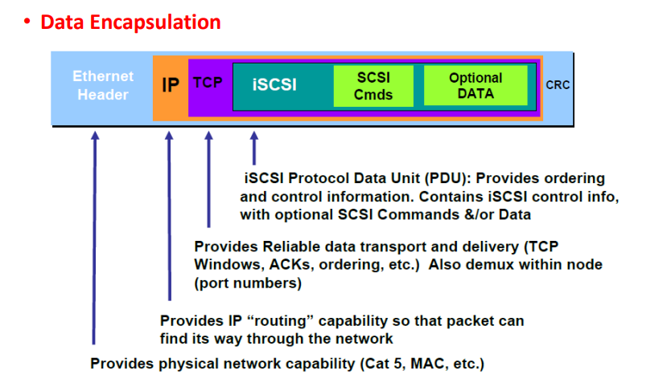

**FC (Fiber Channel) :--****Fiber Channel, or FC, is a high-speed network technology (commonly running at 1, 2, 4, 8, 16, 128 gigabit per second rates) primarily used to connect computer data storage to servers. Fibre Channel is mainly used in Storage Area Networks (SAN) in commercial data centers.**

**FC Node Ports :- • HBA (Host Bus Adapter) in server • Front-end adapters in storage**

**Two Types of Optical Cable:---Single Mode and Multimode.FC cable used for long distance.**

**\*\* Domain ID:--- is a unique number provided to each switch in the fabric 239 addresses are available for domain ID**

**Maximum possible number of node ports in a switched fabric: • 239 domains X 256 areas X 256 ports = 15,663,104**

**Fibre Channel – Frame Dissection;-** **Up to 2048 byte payload4 byte checksum for each frame**

**FCIP (IP SAN Protocol);- IP-based protocol that is used to connect distributed FC**

**SAN islands .Creates virtual FC links over existing IP network that is used to transport FC data between different FC SANs Encapsulates FC frames onto IP packet Provides disaster recovery solution**

**Storage as Service**

**(RAID)**

**RAID (Redundant Array of Independent Disks) :-** **operate independently and in parallel.It is** **storage technology that provides increased reliability and functions through redundancy.**

**Technique combines multiple disk drive components into a logical unit, where data is distributed across drives in one of several ways called "RAID levels" having 7 levels (0-6).**

**1)RAID Level 0: Block striping; non-redundant. Used in high-performance applications where data loss is not critical. RAID 0 is used only when data safety is not important .**

**2) RAID Level 1: Mirrored disks with block striping Offers best write performance. Popular for applications such as storing log files in a database system.**

**3) RAID Level 2: Memory-Style Error-Correcting-Codes (ECC) with bit striping.**

**4) RAID Level 3: Bit-Interleaved Parity a single parity bit is enough for error correction, not just detection, since we know which disk has failed. suitable for applications that demand the highest transfer rates in long sequential reads and writes.**

**5) RAID Level 4: Block-Interleaved Parity; uses block-level striping, and keeps a parity block on a separate disk for corresponding blocks from N other disks.**

**6) RAID Level 5: Block-Interleaved Distributed Parity; partitions data and parity among all *N* + 1 disks, rather than storing data in *N* disks and parity in 1 disk.**

**Round robin allocation for parity strips.** **Commonly used in network servers.**

**RAID- 5 provides the best read throughput of all of the parity models and gives acceptable throughput on write operations.Recommended applications include file and application servers, email and news servers, database and Web servers.**

**7) RAID Level 6: P+Q Redundancy scheme; similar to Level 5, but stores extra redundant information to guard against multiple disk failures. Better reliability than Level 5 at a higher cost; not used as widely.**

**Hardware Issues**

**Software RAID: RAID implementations done entirely in software, with no special hardware support.**

**Hardware RAID: RAID implementations with special hardware Use non-volatile RAM to record writes that are being executed .Beware: power failure during write can result in corrupted Disk. NV-RAM helps to efficiently detected potentially corrupted blocks Otherwise all blocks of disk must be read and compared with mirror/parity block.**

**Latent failures: data successfully written earlier gets damaged can result in data loss even if only one disk fails**

**Data scrubbing: continually scan for latent failures, and recover from copy/parity**

**Hot swapping: replacement of disk while system is running, without power down Supported by some hardware RAID systems, reduces time to recovery, and improves availability greatly.**

**Typical Block Devices:-****Hard Disk Drives (HDDs) Solid State Drives (SSDs) Storage Arrays (RAID) Storage Area Network (SAN) .**

**\*\*FCoE:- is a protocol that transports FC data over Ethernet network (Converged Enhanced Ethernet) FCoE is being positioned as a storage networking option because: Enables consolidation of FC SAN traffic and Ethernet traffic onto a common Ethernet infrastructure .Reduce adapters,switch ports,cables,cost,power, cooling and floor space.**

**Components of an FCoE Network :--****Converged Network Adapter (CNA):-**

**,Cable ,FCoE switch.**

**Two options are available for FCoE cabling• Copper based Twinax cable for shorter distances,** **less power,** **Small Form Factor Pluggable Plus (SFP+) connector**

**• Standard fiber optical cable for Can run over longer distances,** **more expensive,** **Uses Small Form Factor Pluggable Plus (SFP+) connector.**

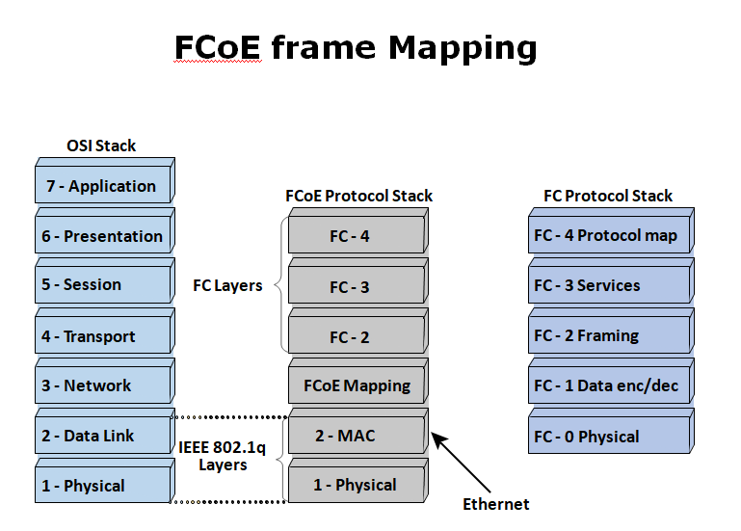

**Converged Enhanced Ethernet :--****Provides lossless Ethernet.**

**functionalities:-****Priority-based flow control (PFC) ,Enhanced transmission selection (ETS) ,Congestion notification (CN) ,Data center bridging exchange protocol(DCBX)**

**File sharing methods:****File Transfer Protocol (FTP) Distributed File System (DFS) Network File System (NFS) and Common Internet File System (CIFS) Peer-to-Peer (P2P)**

# DAS

**DAS** stands for **Direct Attached Storage**. It is a digital storage device connected directly to the server, workstation, or personal computer via the cable. In Direct Attached Storage, applications use the block-level access protocol for accessing the data.

The System of DAS is attached directly to the computer through the **HBA** (Host Bus Adapter. As compared to NAS devices, its device attaches directly to the server without the network.

## Types of DAS

Following are the two types of Direct Attached Storage (DAS):

1. Internal DAS
2. External DAS

### Internal DAS

Internal DAS is a DAS in which the storage device is attached internally to the server or PC by the HBA. In this DAS, HBA is used for high-speed bus connectivity over a short distance.

### External DAS

External DAS is a DAS in which the external storage device is directly connected to the server without any device. In this type of DAS, FCP and SCSI are the protocols which act as an interface between server and the storage device.

# iSCSI

In Computing, **iSCSI** stands for "**Internet SCSI**" or "**Internet Small Computer Systems Interface**". It is an internet protocol which works on the top of [TCP (Transport Control Protocol)](https://www.javatpoint.com/tcp). It is a protocol which is used for linking the data storage components or facilities. Fibre Channel is also an iSCSI, which is used for creating the [SAN (Storage Area Network)](https://www.javatpoint.com/san). ISCI uses the two ports of TCP, whose names are 80 and 3260. It also offers the high-level encryption of data packets which are being transferred.

## How Does iSCSI work?

In Iscsi, block-level data is transferred between the client (iSCSI initiator) and the storage device (iSCSI target). There are lots of iSCSI devices that allow this communication between the client and the storage devices.

When an application or end-user sends a request to access a file, the server converts the SCSI commands into the iSCSI command, and after then packets are sent over the IP network using the point-to-point connection. When the packets have arrived at the receiving side, then the iSCSI protocol disassembles the packets. It then converts these packets into SCSI commands and, finally, issue them to the storage.

## Advantages of iSCSI

Following are benefits or advantages of iSCSI:

* One of the main benefits of iSCSI is that it uses the TCP/IP protocol to enable long-distance IP routing without the requirement of any external gateway hardware. And, it also increases flexibility by using the TCP/IP.
* It uses the standard ethernet, so there is no need for any expensive component to be built.
* As compared to the Fibre channel, it offers the cheap connectivity network for transferring the files at the block level.
* Reusability is also another advantage of iSCSI. The existing server can also be reused for the iSCSI implementation.
* As it is used for block storage, so it is very fast and efficient than other file transfer protocols (FTP).
* It is very simple to understand and configure, so users do not need much knowledge about the iSCSI storage system.

# NAS (Network Attached Storage)

Network-attached Storage (Commonly known as NAS) is a file storage device which is connected to the network and enables multiple users to access data form the centralized disk capacity. The users on a LAN access the shared storage by the ethernet connection.

This storage is fast, low-cost and offers all the advantages of a public cloud on the site. It uses file access protocols such as [NFS](https://www.javatpoint.com/nfs), SMB, NCP, or AFP.

NFS is a file-based protocol which is popular on Unix systems. SMB stands for Server Message Block, which is used with the Microsoft Windows systems. AFP is also a file access protocol that is used with the Apple computers.

It is basically designed for those network systems, which may be processing millions of operations per minute. It supports the storage device for the organization, which need a reliable network system. It is more economical than the file servers and more versatile than the external disks.

# NFS

**NFS** is an abbreviation of the **Network File System**. It is a protocol of a distributed file system. This protocol was developed by the [**Sun Microsystems**](https://www.javatpoint.com/sun-microsystems) in the year of 1984.

It is an architecture of the client/server, which contains a client program, server program, and a protocol that helps for communication between the client and server.

It is that protocol which allows the users to access the data and files remotely over the network. Any user can easily implement the NFS protocol because it is an open standard. Any user can manipulate files as same as if they were on like other protocols. This protocol is also built on the ONC RPC system.

This protocol is mainly implemented on those computing environments where the centralized management of resources and data is critical. It uses the [Transmission Control Protocol (TCP)](https://www.javatpoint.com/tcp) and [User Datagram Protocol (UDP)](https://www.javatpoint.com/udp-protocol) for accessing and delivering the data and files.

# NVMe

NVMe stands for Non-Volatile Memory Express. The meaning of Non-Volatile is that the data in the storage is not erased when our computer reboots.

The protocol of NVMe is built on the top of PCIe lanes.

NVMe is a transport protocol for accessing the non-volatile storage with the technology known as PCI express. This interface is introduced in the year of 2013.

It is basically designed to allow the high-speed transfer of data between the computer components and system.

# SAN

**SAN** is an abbreviation of the **Storage Area Network**. Storage Area Network is a dedicated, specialized, and high-speed network which provides block-level data storage. It delivers the shared pool of storage devices to more than one server.

The main aim of SAN is to transfer the data between the server and storage device. It also allows for transferring the data between the storage systems.

## Protocols of SAN

Following are the most common protocols of SAN (Storage Area Network):

* FCP (Fibre Channel Protocol)
* iSCSI
* FCoE
* NVMe

### FCP (Fibre Channel Protocol)

It is the most commonly used protocol of the Storage Area Network. It is a mapping of SCSI command over the Fibre Channel (FC) network.

### ISCSI

It stands for Internet SCSI or Internet Small Computer System Interface. It is the second-largest block or SAN protocol. It puts the SCSI commands inside an ethernet frame and then transports them over an [Internet protocol (IP)](https://www.javatpoint.com/ip) ethernet.

### FCoE

FCoE stands for "Fibre Channel Over Internet". It is a protocol which is similar to the iSCSI. It puts the Fibre channel inside the ethernet datagram and then transports over an IP Ethernet network.

### NVMe

NVMe stands for Non-Volatile Memory Express. It is also a protocol of SAN, which access the flash storage by the PCI Express bus.

## Advantages of SAN

* It is more scalable.
* Security is also a main advantage of SAN. If users want to secure their data, then SAN is a good option to use. Users can easily implement various security measures on SAN.
* Storage devices can be easily added or removed from the network. If users need more storage, then they simply add the devices.
* The cost of this storage network is low as compared to others.
* Another big advantage of using the SAN (Storage Area Network) is better disk utilization.

**IP SAN:--**An IP SAN is a Storage Area Network that uses the iSCSI protocol to transfer block-level data over a network, generally Ethernet. Initiator. In this document the term "initiator" is used interchangeably to refer to a server, host or device driver that initiates (i.e. begins) iSCSI command sequences.